Task 1: Capturing network packet traffic with Wireshark

Capture Steps:
- Launched Wireshark and selected the active interface (Wi-Fi / Ethernet).
- Began live packet capture and opened a web browser to navigate to instagram.com.
- Stopped the capture once the feed loaded and applied display filters to analyze the traffic.
Observed Protocols in Packet List:
- DNS (Domain Name System): Resolves the domain name instagram.com to its associated public IP addresses.
- TCP (Transmission Control Protocol): Establishes the reliable 3-way handshake (SYN, SYN-ACK, ACK) before data exchange.
- TLSv1.2 / TLSv1.3 (Transport Layer Security): Negotiates cryptographic parameters and carries encrypted HTTPS application traffic.
- QUIC / UDP: Modern browsers frequently communicate with Meta/Instagram edge endpoints over HTTP/3 via UDP port 443.
- ARP (Address Resolution Protocol): Maps the local router’s IPv4 gateway address to its physical MAC address on the local network.

Task 2: Mapping packets to OSI layers

Packet | Protocol | OSI Layer | Purpose
Packet 1 | DNS | Layer 7 – Application | Resolves the website name into an IP address.
Packet 2 | TCP | Layer 4 – Transport | Provides reliable communication between devices.
Packet 3 | TLS | Layer 6 – Presentation | Helps encrypt data during secure communication.

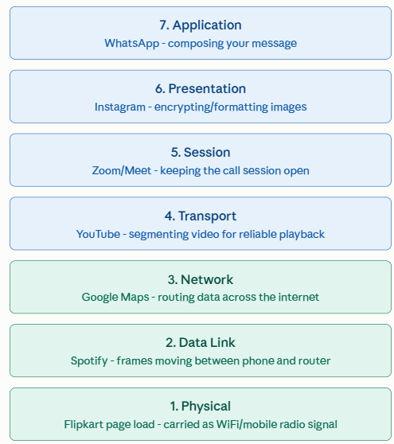
Task 3: The 7-Layer OSI Model with Everyday App Examples

Layer 7: APPLICATION - UI, App APIs, Message Formatting
Example: WhatsApp text protocol, YouTube HTTP/HTTPS API
Layer 6: PRESENTATION - Encryption, Data Compression, Code
Example: TLS/SSL encryption, Instagram JPEG/WebP images
Layer 5: SESSION - Connection State, Dialogue Control, Auth Tokens
Example: WhatsApp persistent device token & state sync
Layer 4: TRANSPORT - Reliable/Unreliable Transport, Port Multiplexing
Example: TCP (WhatsApp delivery receipts), UDP (Voice calls)
Layer 3: NETWORK - Logical Addressing, Global Routing
Example: IP packets traveling across ISPs to Meta edge servers
Layer 2: DATA LINK - Physical Addressing, Local Frame Delivery, Error Check
Example: Wi-Fi (802.11) or Ethernet MAC frame headers
Layer 1: PHYSICAL - Raw Bitstream, Radio Waves, Electrical Signals
Example: 2.4/5 GHz Wi-Fi radio frequencies, Cat6 copper wire

Task 4: How a WhatsApp message travels through the OSI layers

When type "Hello!" and tap Send inside WhatsApp, message travels down the OSI stack from smartphone, across the physical medium, and back up the stack on the receiving end:
- Application Layer (Layer 7): Compose the message in the WhatsApp interface. The application structures the plain text into an internal messaging protocol payload, tagging it with metadata such as recipient ID and timestamp.
- Presentation Layer (Layer 6): Before leaving the device, WhatsApp’s cryptographic engine applies end-to-end encryption (the Signal Protocol). The readable text "Hello!" is transformed into an encrypted, unreadable ciphertext blob that only the intended recipient's private key can decrypt.
- Session Layer (Layer 5): Keeps a continuous connection open between your app and WhatsApp's server, so messages flow back and forth without reconnecting each time.
- Transport Layer (Layer 4): The encrypted message is broken into smaller segments and handed to TCP, which adds port numbers and sequencing so the data arrives complete and in the right order, even if the network is unreliable.
- Network Layer (Layer 3): The transport segment is packaged into an IP packet. The phone stamps its private IP address (source IP) and the WhatsApp gateway server address (destination IP), allowing intermediate routers across your ISP to direct the packet along the fastest available path to the data center.
- Data Link Layer (Layer 2): Packages network data into frames using physical MAC addresses, handles local error detection (CRC), and manages media access control across switches and Wi-Fi access points.
- Physical Layer (Layer 1): Transmits raw, unstructured bitstreams (1s and 0s) as electrical voltages, optical light pulses, or radio frequency signals over physical media like Cat6 cables and Wi-Fi antennas.

